Section IV: Timesheet Management

1. Create Daily Time Log Entry | CPMT-59 |

User Story
As a team member, I want to log my daily working hours against projects so that my effort is recorded accurately.

User Journey
Step 1: User logs into the Calculus application
Step 2: User lands on role-based home screen
Step 3: User clicks “Add work Log” buttons from the landing page.
Step 4: System opens pop-up to Add work logs
Step 5: User selects the date, work log category, Projects, hours and Work description
Step 6: User saves the entry as Draft or submits it

Actors
- Team Member (only individual view)
- Project Lead / Manager
- Team lead
- Admin

Scope
This feature allows users to capture daily time spent on assigned projects without any approval workflow.

Pre-conditions
- User must be authenticated
- Project must be active
- User must be allocated or permitted to log time on the project
- Work log

Assumptions
- Time logging is mandatory for all working days
- Users are responsible for entering accurate data

Impacted Areas
Pages: Timesheet Entry Page
Modules: Timesheet Management

Mock-ups / Prototypes

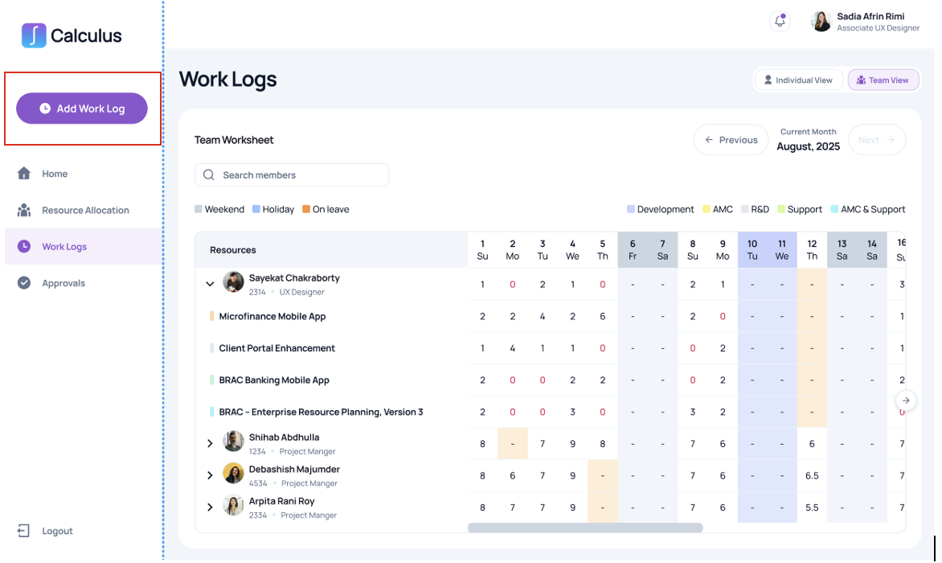
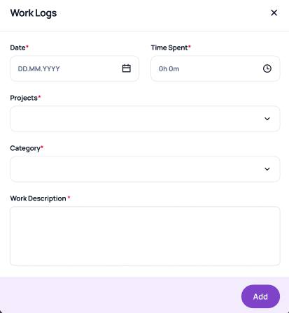

Requirements
- The system must allow users to create daily time log entries and can select any previous date but not beyond the current month.
- All the fields are mandatory.
- Hours must be numeric and greater than zero
- Work Description field must be available
- The system must allow submitting completed entries.
- Without allocation the system will not allow to log
- List of Work log category is static and taken from portfolio manager.
- Project will be searchable from both Brac and BracIT jira and shown list must be assigned to the user.

Acceptance Criteria
- User can successfully log time with valid inputs
- Invalid or missing inputs block submission.
- Data fields validation:
Field Name | Data Type | Validation Logic | Validation Message | Message Appearance
Date | Date Picker | Required; Must be a valid date; Cannot be a future date | "Date is required" / "Please enter a valid date" | Inline
Time Spent | Time (Duration) | Required; Format: 0h 0m; Must be greater than 0 | "Time spent is required" / "Time must be greater than 0" | Inline
Projects | Dropdown (Enum) | Required; Must select one project from the list (Project category same as project creation process) | "Please select a project" | Inline
Category | Dropdown (Enum) | Required; Must select one category from the list (list from Portfolio manager) | "Please select a category" | Inline
Work Description | Text Area (String) | Required; Min 10 chars; Max 500 chars | "Description is required" / "Minimum 10 characters required" | Inline

Exceptions
- If project is archived, it must not be selectable

2. View Log Entries | CPMT-59 |

User Story
As a user, I want to view my previously created log entries so that I can review historical work updates.

User Journey
Step 1: User opens “Work Logs” module
Step 2: System displays list of historical log entries in individual view.
Step 3: User can check entries from previous months.
Step 4: User view log details

Actors
All the users

Scope
This feature provides visibility of historical log entries based on role permissions.

Pre-conditions
- Log entries must exist.

Impacted Areas
Pages: Log Entry individual and team view, individual dashboard, project detail page.
Modules: Work Logs

Mock-ups / Prototypes
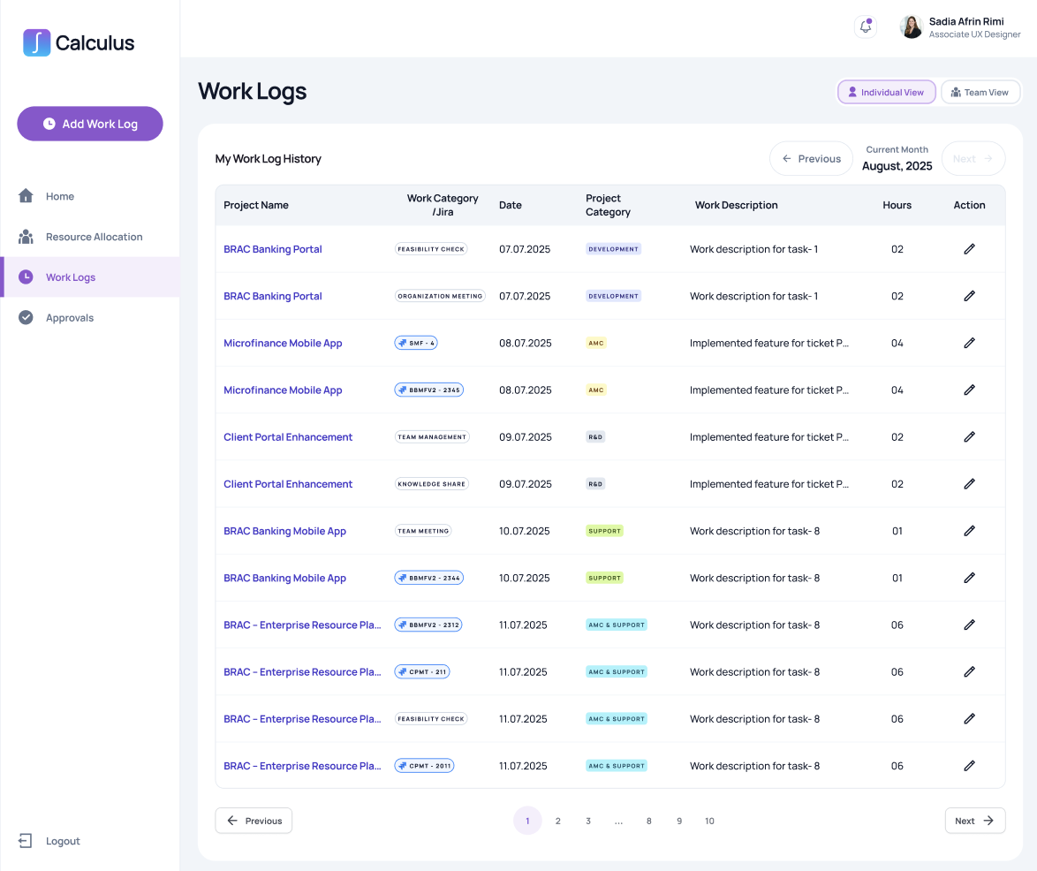

Requirements
- The system must display log entries in reverse chronological order with data of project name, work category, date, project category, work description, logged hours and action button to edit log hours.
- The system must support showing project name, work category, date, project category, work description as it is shown in the prototype.
- The system must show worklog hours in hours and minutes.
- Team members must see only their own entries in individual view.
- Team Leads, project leads and Admins must see team entries with team view.
- The system will support month filter to view the worklogs

Technical Requirements
- Pagination must be supported for large datasets

Acceptance Criteria
- Users can view permitted log entries
- Filters return correct results.

Exceptions
If no logs exist, system displays “No Log Entries Found”

3. Edit work log | CPMT-59 |

User Story
As a user, I want to edit my draft timesheet entries so that I can correct or complete them before submission.

User Journey
Step 1: User navigates to “Work Logs” module or Timesheet Table from Landing page.
Step 2: User selects a date with historical entries> action button/edit button
Step 3: User edits hours, remarks/description, and other necessary details.
Step 4: User saves the updated entry

Actors
- All users

Scope
This feature allows modification of timesheet entries before submission.

Pre-conditions
- User must be the creator of the entry
- User can change log entry for current month only, but exception can be allowed in first 5 days of every month when the user can edit logs of previous month. Reports should be recalculated and updated as per changes.
- User can change the description only for the Jira logs and for the logs in calculus, user can edit work category, date, work description and hours.
- Based on the past worklogs edited KPIs will be affected and recalculated but historical reports will not be affected.

Impacted Areas
Pages: Timesheet Entry Page
Modules: Timesheet Management

Mock-ups / Prototypes


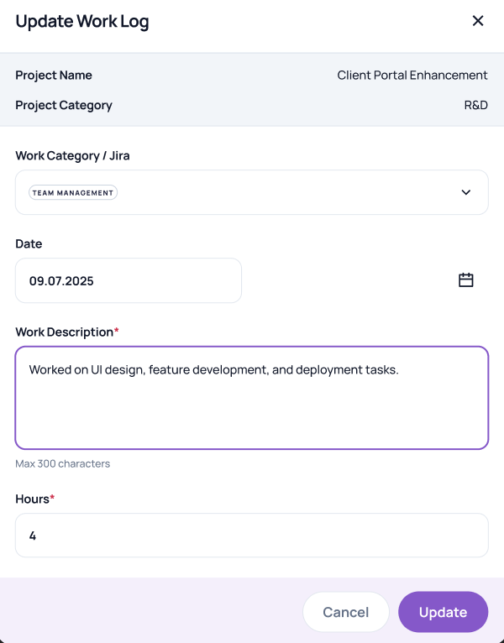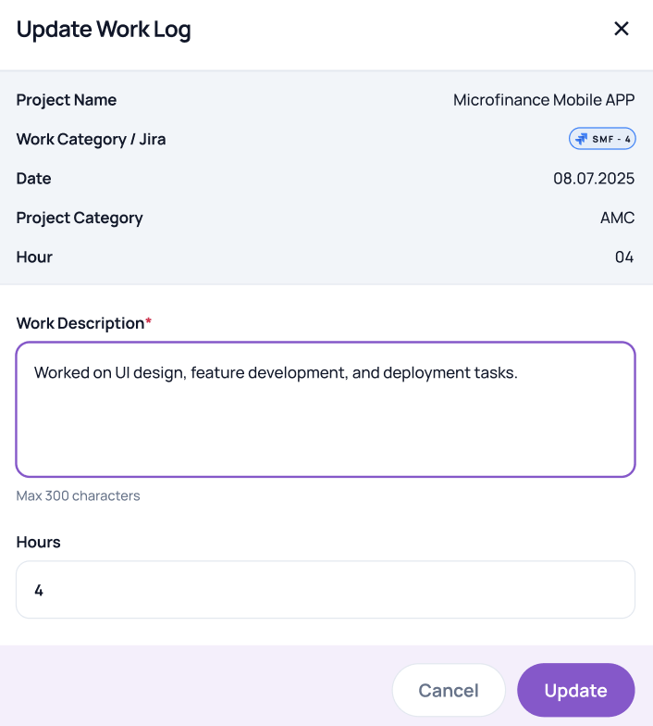

Requirements
- The system must allow editing of previous entries in current month only.
- The user can see previous month logs but can’t edit except first 5 days of every month
- User can change log entry for current month.
- User can change the description only for the Jira logs and for the logs in calculus, user can edit work category, date, work description and hours. Work description should be text to 500 characters at max.
- Changes must be saved successfully

Non-Functional Requirements
Edit actions must not cause data loss

Acceptance Criteria
- Submitted entries will be shown properly.
- Any changes in the logs should be reflected on real time basis.
- Action button for editing should work properly.

Exceptions
If entry is locked by system policy, edit must be blocked

4. Search and Filter Log Entries for team| CPMT-59

User Story
As a user (Project lead), I want to search and filter log entries so that I can quickly locate specific work records.

User Journey
Step 1: User opens “Work Log” module
Step 2: User enters Team View switching from individual view
Step 3: System refreshes list based on month filter and search option by team member name

Actors
- Team Member
- Project Lead / Manager
- Admin

Scope
This feature enables efficient retrieval of log entries using filters and search.

Pre-conditions
- Log entries must exist

Impacted Areas
Pages: Log Entry List View
Modules: Log Entry Search

Mock-ups / Prototypes
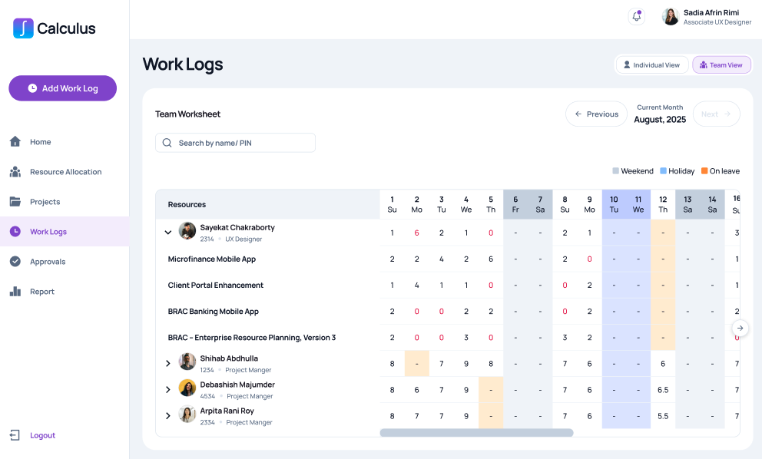

Requirements
- The system must support filtering by month.
- The system must support keyword search in extended view of closely matched resources.
- Dropdown button beside individual resources will show the logs among projects connected to that individual.
- Filter state must persist during session

Technical Requirements
- Search queries must be optimized
- Backend APIs must support pagination and filtering parameters

Acceptance Criteria
- Search returns accurate results
- Filters work independently and together
- Results match applied criteria

Exceptions
If no results match, system displays “No Matching Log Entries Found”

